INSTRUCTIONS FOR WORKING WITH E-SUBMISSION SYSTEM

- Sign in

To work in e-submission system you need to register. To do this, go to the website https://journals.spbstu.ru/ and click "Register".

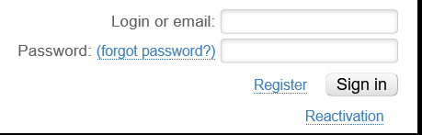
After clicking the “Register” button, you should fill in all the required fields.
Please note that in the “Initials in English” you should write first letter(s) of your first (given) name (or names). It is highly appreciate to mention your ORCID, Scopus ID and other identifiers.
Also, please, enter the current contact information to simplify communication with the editors and update them as they change.
We also recommend you to add a profile photo. Permitted photo formats: .jpg, .png, .gif. The size of the uploaded photo should not exceed 3 Mb.
In order to change your personal data, go to “Personal profile” page and click the “Edit profile” button at the bottom of the page. The profile editing form will be opened. Make the necessary changes and click the “Save” button at the bottom of the page. Please check the information correctness as it will be used in your articles.

- Start of article submission

After registering in the system, you need to log in to your personal account. In the menu on the right side of the web page, select "My articles".

On the page that opens, select "Submit article". A form for adding a new article will appear on the screen. Items marked with a * are required. Keywords can consist of one or more words and must be separated by commas.

- Data input

On the page that opens, you need to fill in all the information about your publication.
To start, fill in the full name of the authors. Your full name will shows up automatically. To add a co-author, start entering their last name. Click the " + " button next to the text box to add a co-author to the list. When you click on a list item, you can change the order in which the co-author is mentioned by using the ↑ and ↓ arrows next to the list. Please note that all authors of the article must be registered in the system, otherwise you will not be able to add them as co-authors.

Further, fill in each section.

In the "Journal" field, select "Sustainable Development and Engineering Economics".
In the "issue" field, you should select #1, and in the "section" field – the most appropriate journal section for your article.
In the "Type of publication" field, select «Scientific article».
- Attaching the file with the article.

Please use the .docx format. The document should include only the text of the article (Introduction, Literature Review, Materials and methods, Results, Discussion, Conclusion, Acknowledgements). References list, the title of the article, and all information about the authors are provided through other fields in this web page.

- References

The list of references is submitted separately from the text of the article through the corresponding field.
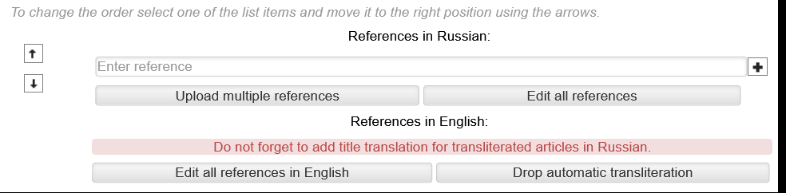
You can download the entire list of sources at once by clicking "Upload multiple references" and copying it to a separate field:
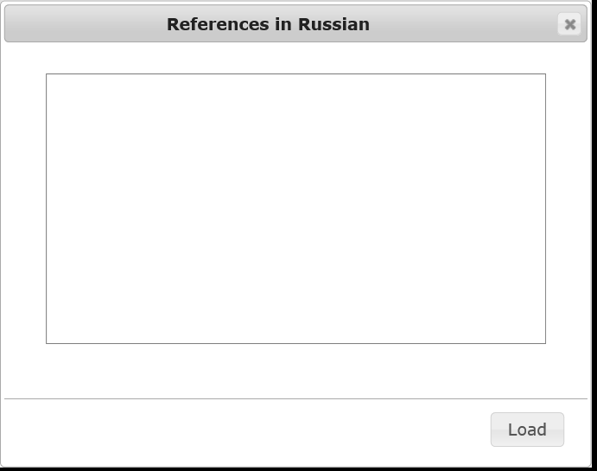
Or upload each source separately in the order in which they are listed in your list of references (note that you need to insert literature sources in the Elsevier style (numeric, with titles). All Russian sources will be automatically transliterated.

- Final submission of the article

After filling in all the required fields, you need to save the article.
After saving, the article is in draft mode. It is not visible to other users of the system and you can still edit it. After editing, go through "My Articles" to the article page by clicking on its title, and click the "Submit" button, which is located in the "Author Action Panel" section. The article will go into an editable state, and the editorial board will receive a notification that your article is ready for review.

